

Component 3 – Advanced Web Engineering

Submitted By: Alisha Dhakal (C7229119) Submitted To: Pratik Shrestha

Table of Content

1. Laravel Installation Version …………………………………………………………….3

2. Laravel Routing …………………………………………………………………………3

3. Code Screenshots .……………………………………………………………………….6

4. UI/UX Output …...……………………………………………………………………….7

5. Repository Link .………………………………………………………………................11

* Laravel Version

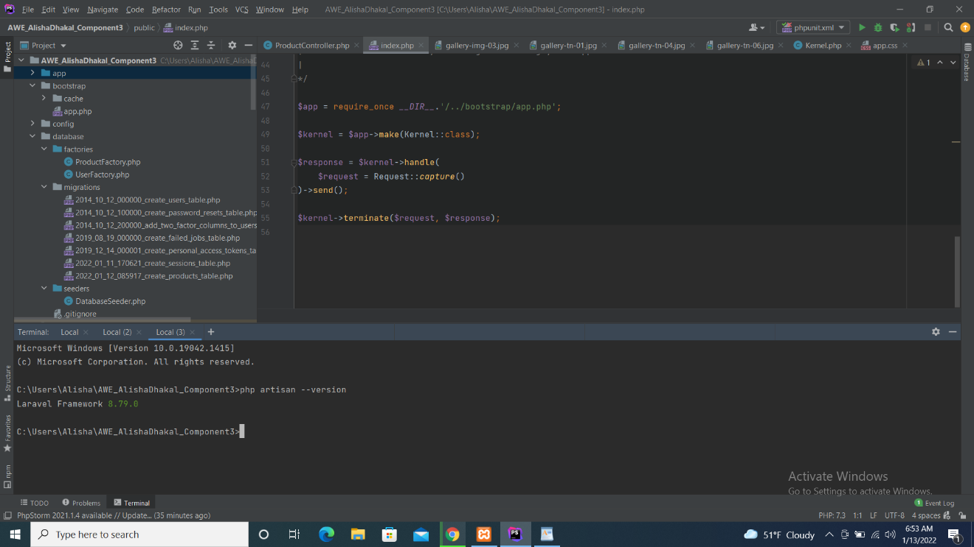

Fig: Laravel Installation

* Laravel Routing

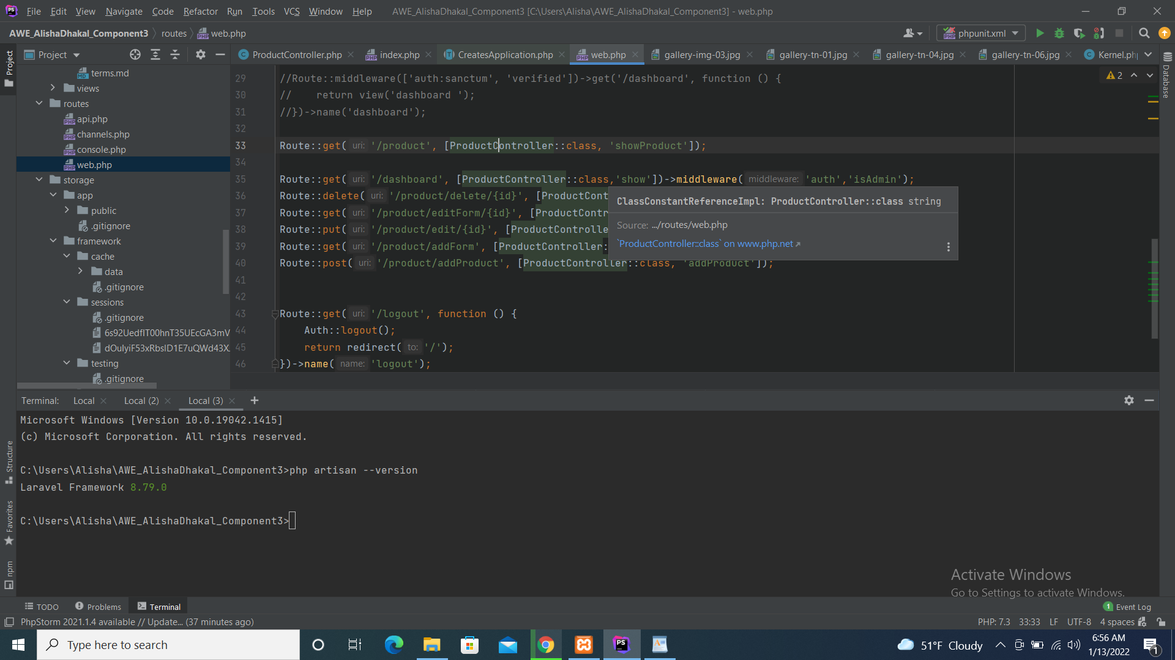

Fig: Screenshot of Laravel Routing inside Resources/Routes

* Code Screenshots

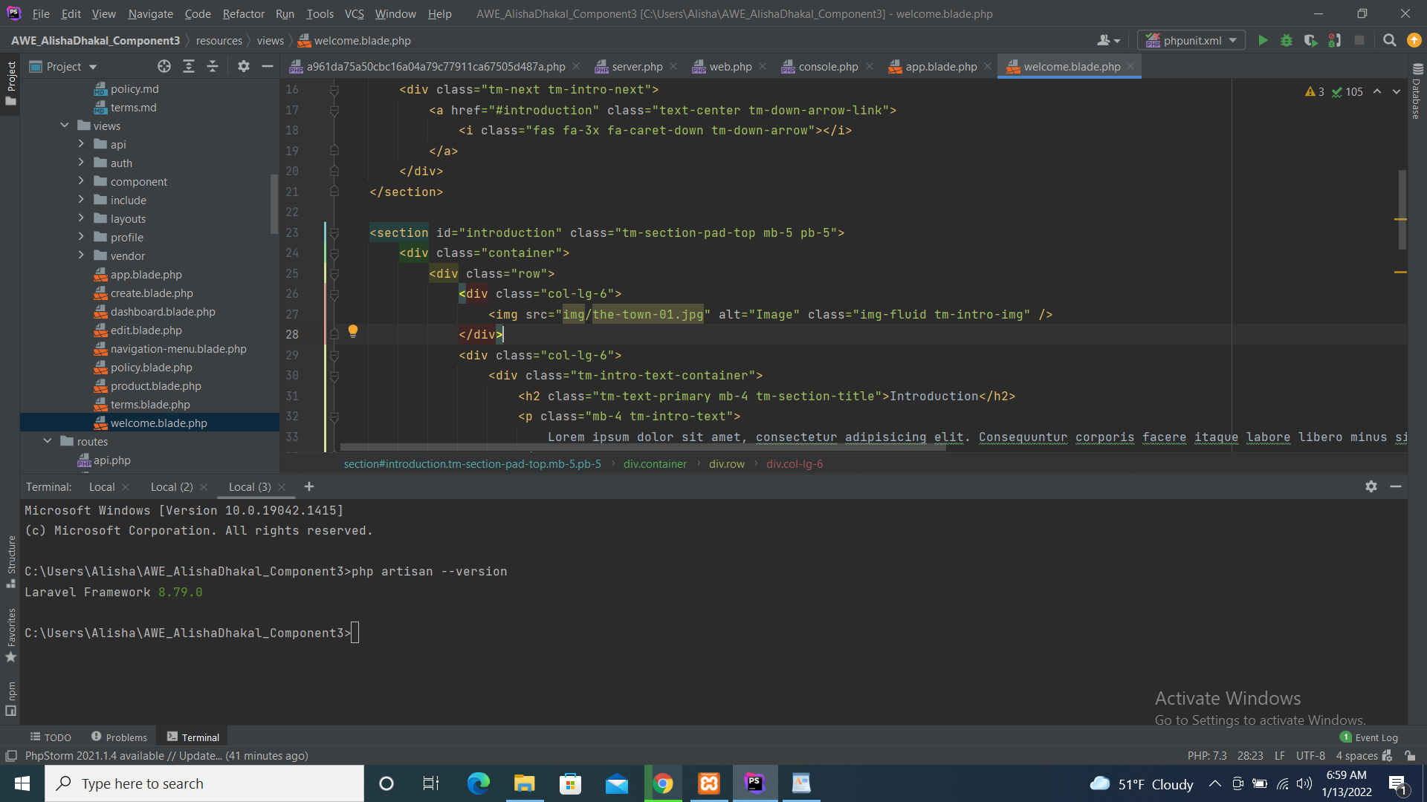

Fig: Screenshot of code

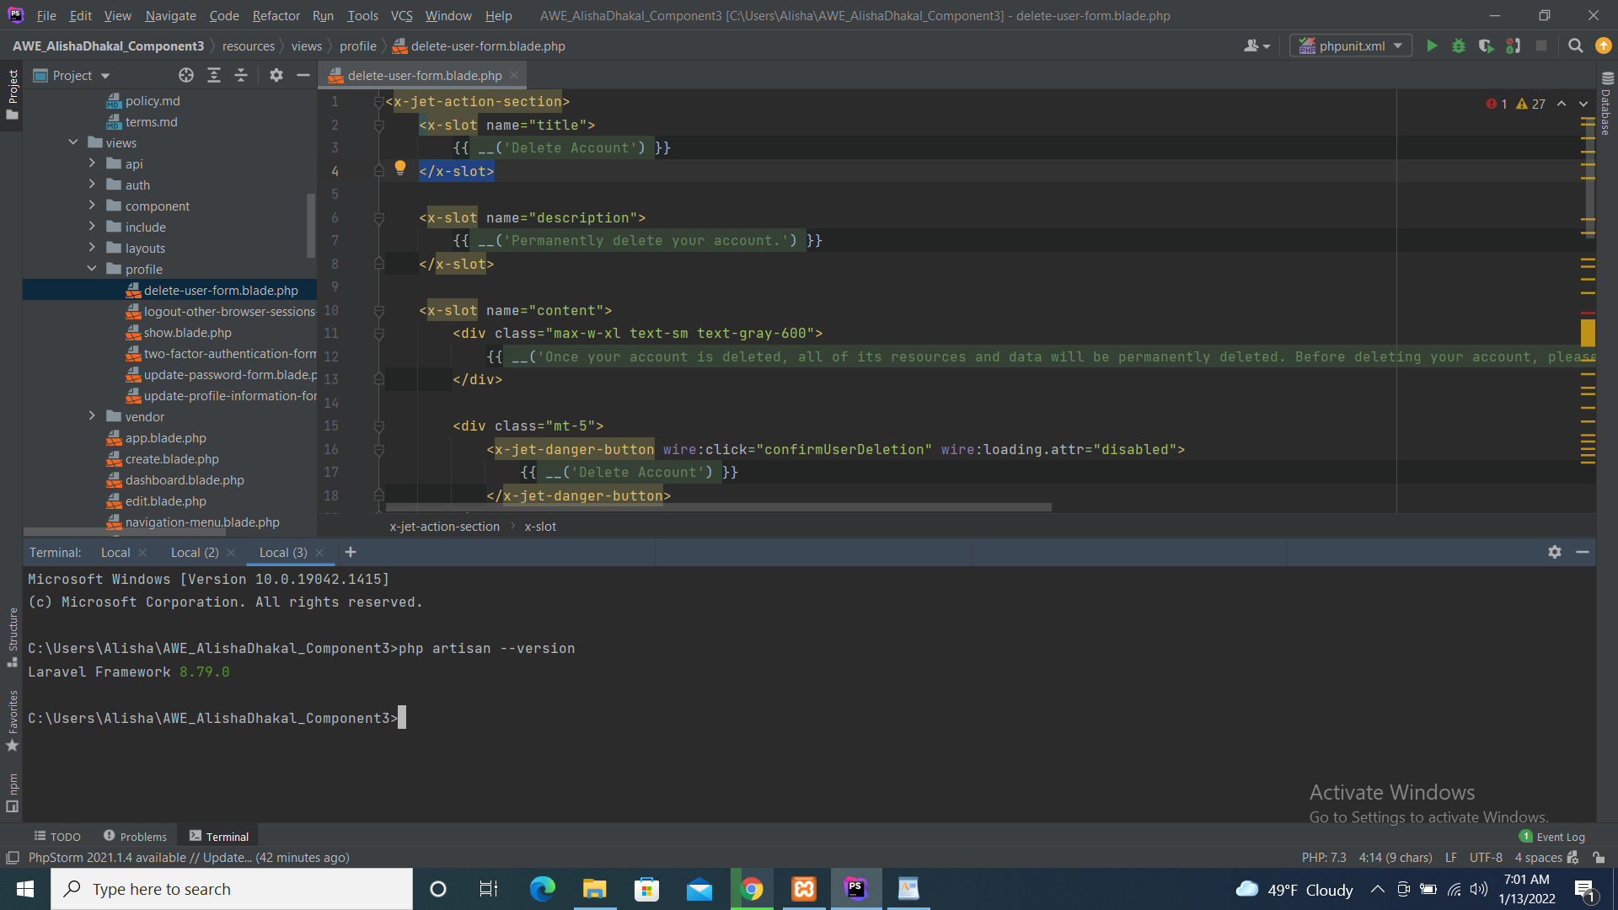

Fig: Screenshot of view



Fig: Screenshot of Model (User)

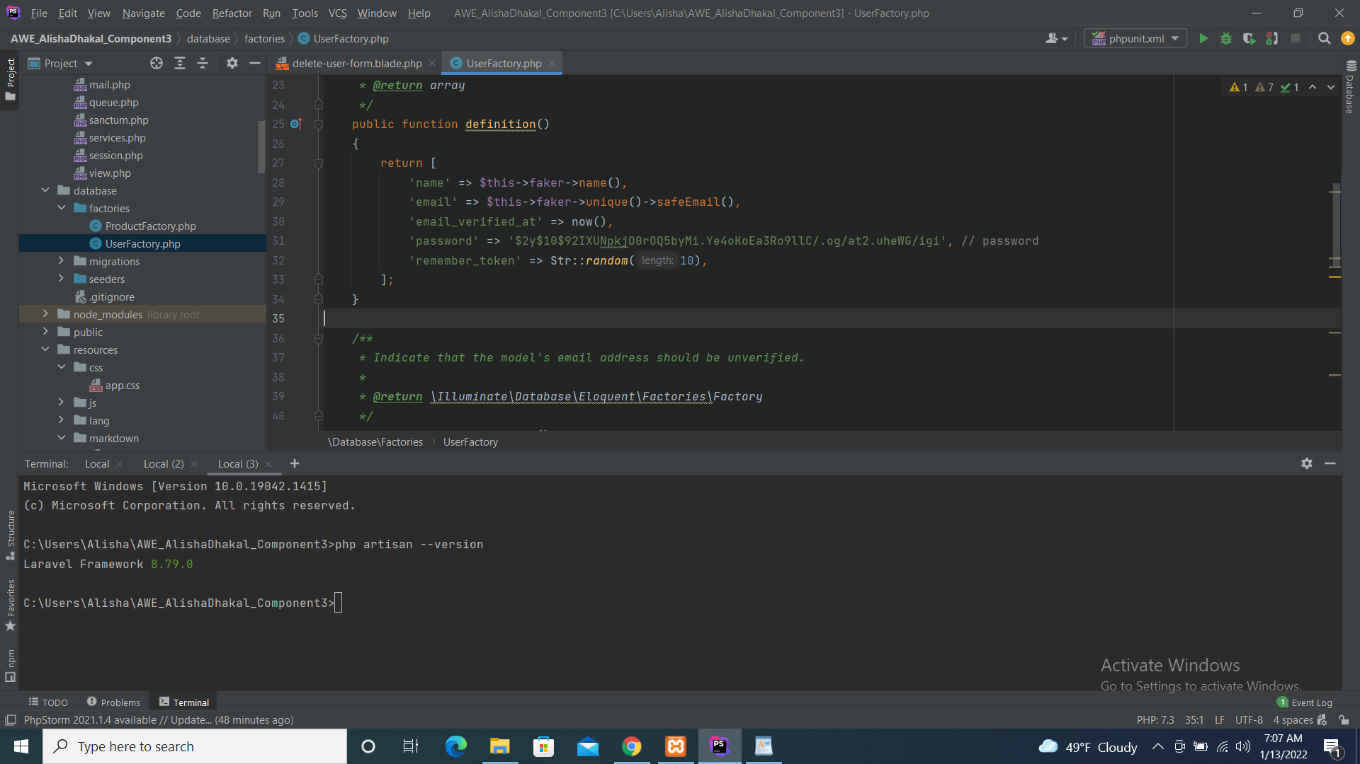

Fig: Screenshot of User Factory

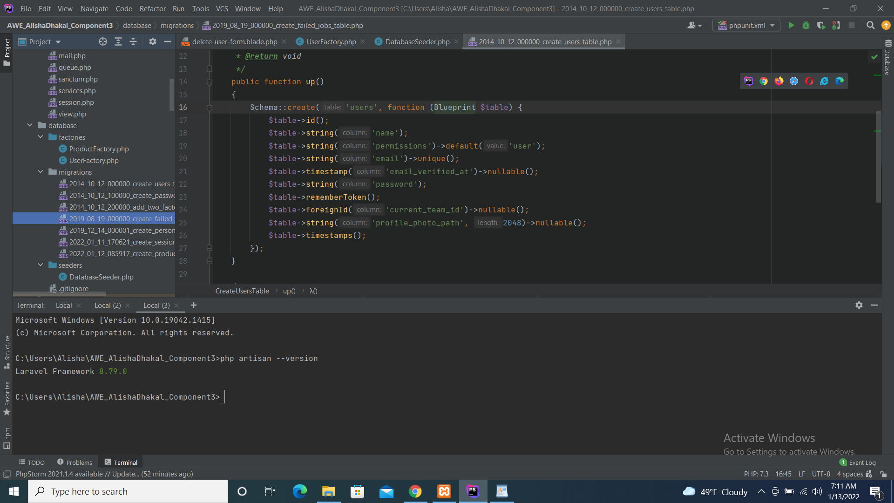

Fig: Screenshot of Migration

4.UI/UX OUTPUT

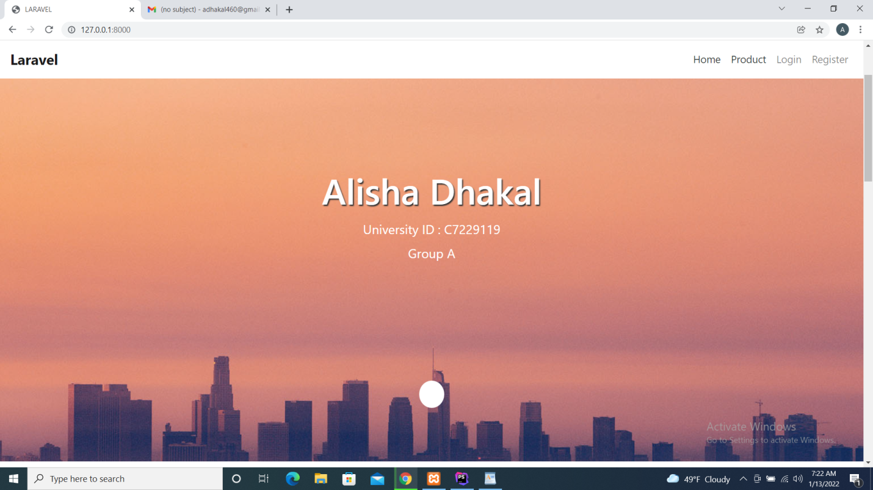

Fig: Output for Homepage

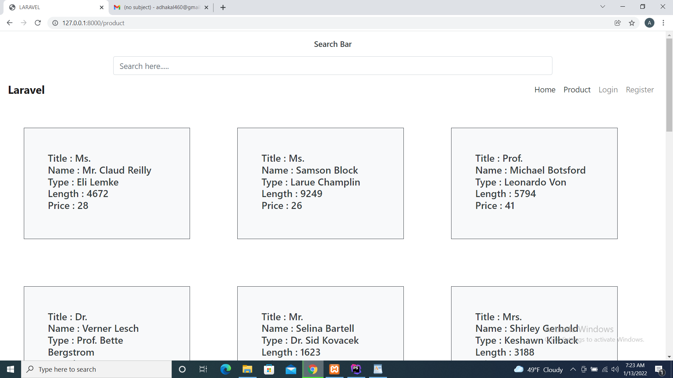

Fig: Output for Productpage

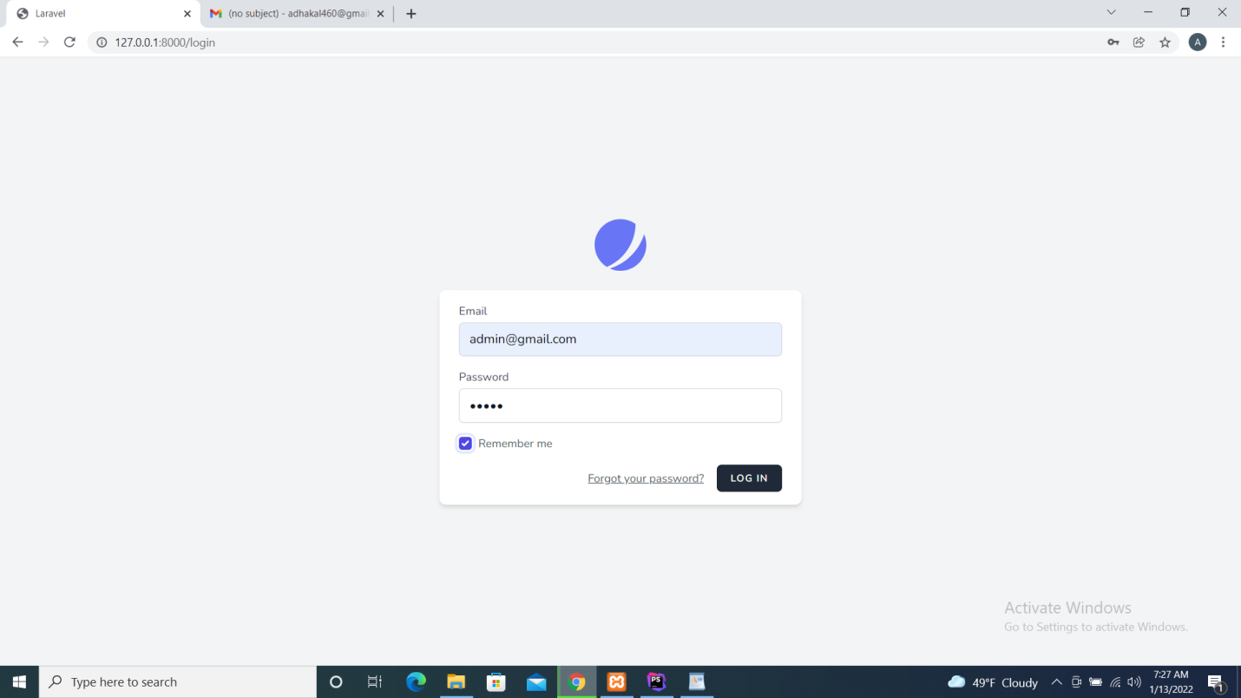

Fig: Output for register page

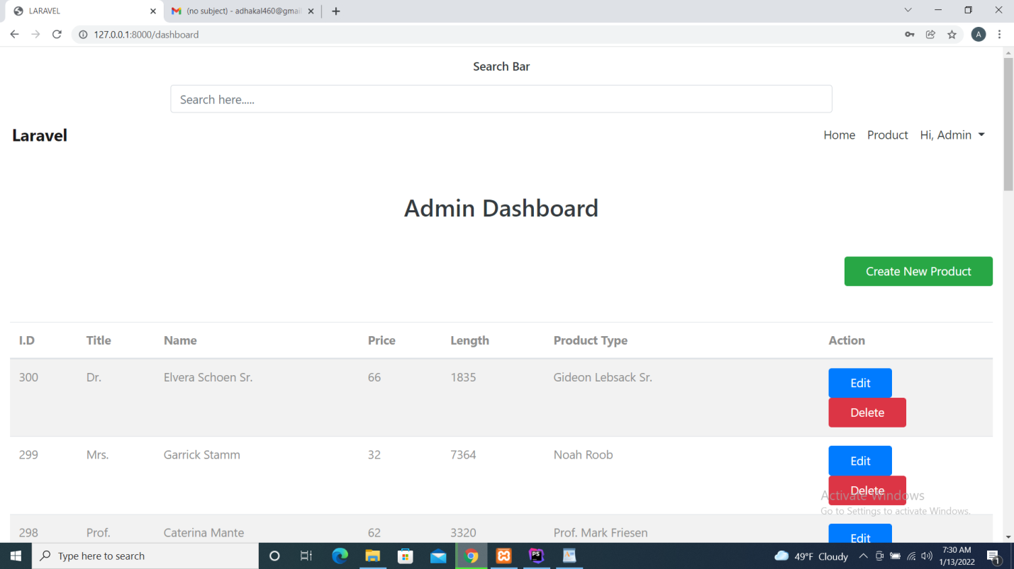

Fig: Output for Admin Dashboard

1. Repository Link

<https://github.com/alishaDhakal/comp2and3.git>